The Islamia University of Bahawalpur

Department of Information Technology

Software Design Document (SDD)
for
Face Recognition Attendance System

Version 1.0

Submitted by
Sonia Zafar (S25BINFT7M04019)
Submitted to
Dr. Dost Muhammad Khan

R
Table of Contents
1. Introduction
1.1. Purpose
1.2. Scope
1.3. Overview
1.4. Reference Material
1.5. Definitions and Acronyms
2. System Overview
3. System Architecture
3.1. Architectural Design
3.2. Decomposition Description
3.3. Design Rationale
4. Data Design
4.1. Data Description
4.2. Data Dictionary
5. Component Design
6. Human Interface Design
6.1. Overview of User Interface
6.2. Screen Images
6.3. Screen Objects and Actions
7. Requirements Matrix

1. Introduction

1.1. Purpose
The Face Recognition Attendance System aims to modernize the traditional attendance process by leveraging facial recognition technology. This document provides the architectural, functional, and technical design for the system, which is built using Python, Django, and advanced facial recognition libraries. By automating the attendance process, the system minimizes human errors, boosts efficiency, and improves security. The goal of this document is to guide the development process and provide a comprehensive understanding of how each component interacts to deliver the desired functionalities.

1.2. Scope
The system is intended to automate the process of attendance marking using facial recognition technology. It consists of a web-based user interface, a backend server (developed using the Django framework), and a facial recognition module. The system features user registration, real-time face detection, attendance management, and an admin dashboard for generating reports. The attendance records are stored in a database for efficient retrieval and historical tracking.
The scope of this document covers:
- High-level architecture and design
- Functional and non-functional requirements
- Data flow and process flow
- Component interaction and system modules
- Database design
- Facial recognition process
- API design
- Security measures

1.4. Reference Material
The Reference Material section provides a collection of key resources, tools, libraries, and technologies used in the design and development of the Face Recognition Attendance System. This section will also include helpful documentation, tutorials, and best practices to support developers and system administrators throughout the project lifecycle.

11.1 Frontend Technologies
- HTML (Hypertext Markup Language)
  - URL: https://developer.mozilla.org/en-US/docs/Web/HTML
  - Description: HTML is the standard language for creating web pages. It is used to structure content on the web, such as user registration forms, the attendance dashboard, and other interactive elements of the system.
- CSS (Cascading Style Sheets)
  - URL: https://developer.mozilla.org/en-US/docs/Web/CSS
  - Description: CSS is used to style HTML elements, enabling developers to create visually appealing and responsive user interfaces. This documentation covers layout design, positioning, typography, and theming for the frontend.
- JavaScript
  - URL: https://developer.mozilla.org/en-US/docs/Web/JavaScript
  - Description: JavaScript is a powerful scripting language used to make the web pages interactive and dynamic. JavaScript handles frontend functionalities such as capturing webcam input for facial recognition, dynamically updating attendance status, and managing user interactions with the system.
- Bootstrap (Optional for Frontend Design)
  - URL: https://getbootstrap.com/
  - Description: Bootstrap is a popular front-end framework for developing responsive and mobile-first websites. It provides a variety of components such as forms, buttons, modals, and grids that can speed up development of the web interface.
- jQuery (Optional for DOM Manipulation)
  - URL: https://jquery.com/
  - Description: jQuery is a fast, small, and feature-rich JavaScript library. It simplifies HTML document traversal and manipulation, event handling, and animation. It can be used for handling user interactions in the attendance system, though it’s optional since modern JavaScript frameworks and native DOM manipulation are often used in conjunction with modern development practices.

11.2 Backend Technologies
- Django Documentation
  - URL: https://docs.djangoproject.com/
  - Description: Django is the web framework used to build the backend of this system. This documentation covers all aspects of Django, including setting up views, models, templates, forms, user authentication, database management, and RESTful API development using Django REST Framework.
- Django REST Framework (DRF)
  - URL: https://www.django-rest-framework.org/
  - Description: Django REST Framework is a powerful and flexible toolkit for building Web APIs in Django. In this system, it helps to manage API endpoints for user registration, face recognition, and attendance management. The documentation explains how to create and handle API views, serializers, authentication, and permissions.
- Python Programming Language
  - URL: https://www.python.org/doc/
  - Description: Python is the primary language used for both the backend logic and the facial recognition algorithms. The official Python documentation provides essential information about Python syntax, libraries, and tools.
- SQLite / PostgreSQL / MySQL (Database Management)
  - URL (SQLite): https://www.sqlite.org/docs.html
  - URL (PostgreSQL): https://www.postgresql.org/docs/
  - URL (MySQL): https://dev.mysql.com/doc/
  - Description: These are the database management systems (DBMS) used to store user data, attendance logs, and reports. Depending on your choice of database, these official resources provide documentation on database design, management, and querying techniques.

1.5. Definitions and Acronyms
The Definitions and Acronyms section provides clear explanations of key terms, concepts, and abbreviations used throughout the Face Recognition Attendance System documentation. This section ensures that the terminology is well-understood, promoting clarity and a common understanding among developers, system administrators, and stakeholders involved in the project.

1.5.1 Definitions
- Attendance System
  - Definition: A software application designed to track and record the presence of individuals in an organization or institution. In this system, attendance is automatically recorded based on facial recognition.
- Facial Recognition
  - Definition: A biometric technology that identifies or verifies a person’s identity based on their facial features. In this system, facial recognition is used to identify users and mark their attendance.
- Webcam
  - Definition: A small camera connected to a computer or device used to capture images or video in real-time. The system uses the webcam to capture live facial images for recognition.
- User Registration
  - Definition: The process where individuals (users) register their facial data (face images) in the system, which is later used for identification during attendance marking.
- Backend
  - Definition: The part of the system responsible for managing data, performing logic, and serving API requests. The backend is typically composed of the server, database, and application logic, built using Django in this system.
- Frontend
  - Definition: The client-side part of the application that users interact with. The frontend is responsible for presenting data, handling user input, and sending requests to the backend. In this system, it is built using HTML, CSS, and JavaScript.
- API (Application Programming Interface)
  - Definition: A set of protocols and tools that allow different software applications to communicate with each other. In this system, APIs are used to manage user interactions, attendance tracking, and reporting between the frontend and backend.
- Authentication
  - Definition: The process of verifying the identity of a user or system. In the context of this system, authentication ensures that only registered users can mark their attendance and access certain system features.
- Attendance Log
  - Definition: A record that tracks the attendance of users. It contains information such as the user’s identity, the time and date of their attendance, and any relevant remarks.
- Dashboard
  - Definition: A user interface element that presents an overview of the system’s data, including attendance reports, user activity, and other important metrics. Dashboards are often customizable and provide actionable insights to administrators.
- Machine Learning
  - Definition: A type of artificial intelligence (AI) that enables systems to automatically learn from data and improve over time. In this system, machine learning techniques are used to recognize faces more accurately and efficiently.
- Face Detection
  - Definition: The process of identifying the presence of a face in an image or video stream. Face detection is the first step before face recognition can take place.
- Face Matching
  - Definition: The process of comparing a detected face to a database of registered faces to determine a match. In this system, face matching is used to identify users during the attendance marking process.
- Database
  - Definition: A structured collection of data stored and managed by a database management system (DBMS). The system uses a database to store user profiles, attendance logs, and system configurations.
- User Profile
  - Definition: A record in the system that contains personal information about a user, such as their name, registration details, facial data, and attendance history.

1.5.2 Acronyms
- API
  - Full Form: Application Programming Interface
  - Definition: A set of protocols for building and interacting with software applications. APIs allow for communication between different software components.
- CSS
  - Full Form: Cascading Style Sheets
  - Definition: A style sheet language used to define the presentation of web pages, including layout, colors, fonts, and overall design.
- Django
  - Full Form: Django is not an acronym but the name of a popular Python-based web framework.
  - Definition: Django is a high-level Python web framework that enables rapid development of secure and maintainable websites. It is used to build the backend of the system.
- HTML
  - Full Form: Hypertext Markup Language
  - Definition: The standard markup language used to create web pages. It structures the content on the page, such as headings, paragraphs, links, and multimedia.
- JS
  - Full Form: JavaScript
  - Definition: A scripting language used to create dynamic and interactive effects within web browsers. JavaScript is used in the frontend of this system to manage user interactions.
- OCR
  - Full Form: Optical Character Recognition
  - Definition: A technology used to convert different types of documents—such as scanned paper documents or PDFs—into editable and searchable data. While this system doesn’t directly use OCR, it may be relevant in systems involving ID card verification.
- REST
  - Full Form: Representational State Transfer
  - Definition: An architectural style for designing networked applications. RESTful APIs are used in this system to allow the frontend and backend to communicate over HTTP.
- SQL
  - Full Form: Structured Query Language
  - Definition: A programming language used to manage and manipulate relational databases. SQL is used to interact with the database to perform queries, updates, and other data-related operations.
- URL
  - Full Form: Uniform Resource Locator
  - Definition: The address used to access resources on the web. In this system, URLs are used to access various endpoints like the user dashboard, attendance reports, and other system pages.
- UI
  - Full Form: User Interface
  - Definition: The part of the system that users interact with. It includes the design, layout, and elements that allow users to interact with the application, such as buttons, forms, and menus.
- UX
  - Full Form: User Experience
  - Definition: Refers to the overall experience and satisfaction of a user when interacting with the system. A good UX design focuses on ease of use, responsiveness, and intuitive navigation.
- URL
  - Full Form: Uniform Resource Locator
  - Definition: The address used to access resources on the web. In this system, URLs point to different pages and endpoints, such as user dashboards or attendance records.
- AWS
  - Full Form: Amazon Web Services
  - Definition: A comprehensive cloud computing platform provided by Amazon, which offers cloud storage, computing power, databases, and other services useful for hosting and scaling web applications.
- HTTP
  - Full Form: Hypertext Transfer Protocol
  - Definition: A protocol used for transferring data over the web. HTTP is used for making requests from the frontend to the backend, such as submitting a face image for recognition or retrieving attendance data.
- HTTPS
  - Full Form: Hypertext Transfer Protocol Secure
  - Definition: A secure version of HTTP, where the communication between the client and the server is encrypted, ensuring data privacy and integrity.

2. System Overview
The Image AI platform is a Software as a Service (SaaS) application that allows users to generate high-quality images from text prompts using advanced AI models like ChatGPT-4. It provides an intuitive web interface for users to input descriptive text and receive AI-generated images. The platform supports an admin panel for managing API configurations, model switching, and monitoring system usage. It operates on a subscription model, offering various plans to suit individual and business needs.

Key Features:
- Text-to-Image Generation: Users generate images based on text prompts.
- AI Model Switching: Admins can select between different AI models for image generation.
- Admin Panel: Manage settings, monitor usage, and configure models.
- Subscription Plans: Multiple pricing tiers to fit different user needs.
- User Authentication: Secure sign-up and login for users.
- Image Management: Users can save, download, or share generated images.
.

3. System Architecture
The System Architecture of the Face Recognition Attendance System is built using a Client-Server Model, where the Frontend interacts with the Backend to manage face recognition and attendance tracking. The architecture involves distinct layers: the Frontend (client-side), Backend (server-side), Face Recognition Module, and the Database.

3.1. Architectural Design

3.1. Architectural Design
1. Frontend (Client-Side)
- Technologies: HTML, CSS, JavaScript
- Responsibilities: Provides the user interface for registering, logging in, and marking attendance. It communicates with the backend via API calls for face recognition and attendance management.
2. Backend (Server-Side)
- Technologies: Django, Django REST Framework
- Responsibilities: Manages business logic, user authentication, and stores user data and attendance records. The backend processes requests and communicates with the Face Recognition Module.
3. Face Recognition Module
- Technologies: OpenCV, Dlib, Face Recognition Library
- Responsibilities: Detects faces from webcam input and compares them to stored data in the database for identification.
4. Database
- Technologies: SQLite/PostgreSQL/MySQL
- Responsibilities: Stores user profiles (facial data) and attendance records.
5. Webcam (User Device)
- Technologies: JavaScript
- Responsibilities: Captures live video to detect and recognize faces for attendance marking.

3.1.1 Interaction Flow
- User interacts with the frontend to register or login.
- The Frontend sends requests to the Backend via API calls.
- The Face Recognition Module processes webcam data, detects faces, and matches them to the database.
- Attendance Data is logged in the Database if a match is found.
- Reports on attendance can be generated and viewed on the Frontend.
Flow Diagram

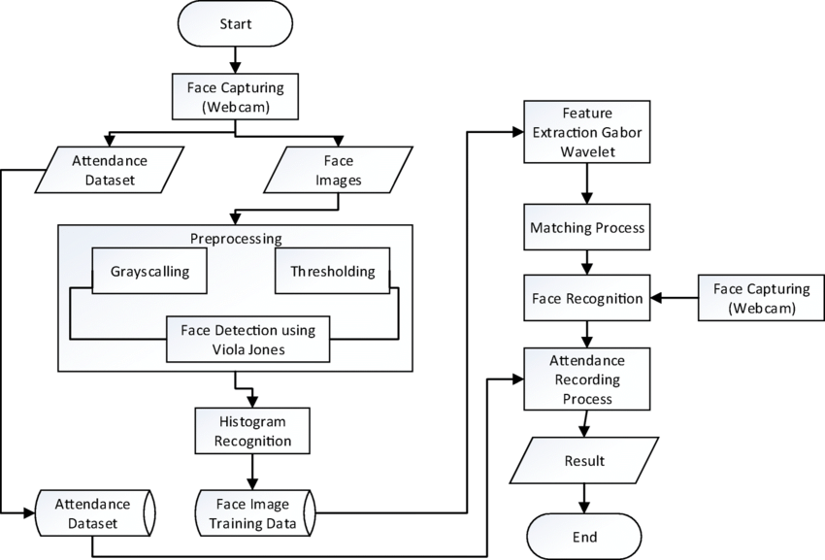
Use Case Diagram
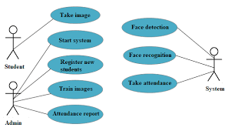
Sequence Diagram
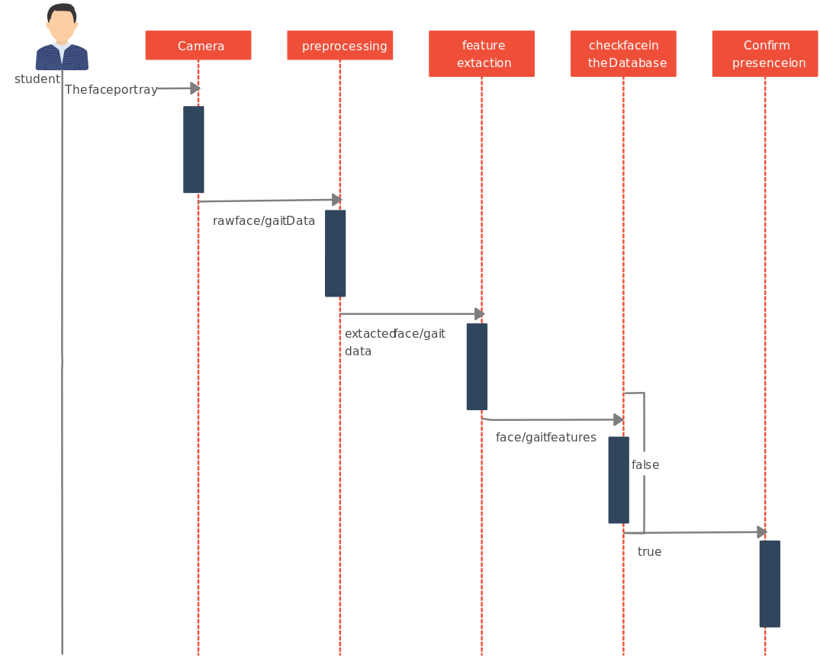

3.2. Decomposition Description
The Decomposition Description breaks down the Face Recognition Attendance System into smaller, manageable components. Each component is responsible for a specific function within the system, ensuring modularity and clarity in the design. Below is a description of each major component in the system:

1. Frontend (Client-Side)
Responsibilities:
- The frontend is responsible for interacting with the user and displaying the user interface.
- It allows users to register, log in, and mark attendance using facial recognition.
- It also displays reports and attendance logs to administrators and users.
Key Features:
- User Interface: Created with HTML and CSS to design the layout and structure.
- JavaScript: Manages dynamic behaviors, like webcam interaction for capturing facial images for recognition.
- API Calls: Sends requests to the backend to handle user registration, login, and attendance tracking.
Components:
- Registration Form: Allows users to sign up and upload their facial data.
- Login Form: Enables users to authenticate before using the system.
- Webcam Interface: Captures video for face detection and recognition.

2. Backend (Server-Side)
Responsibilities:
- The backend is responsible for handling requests from the frontend, processing logic, and interacting with the database.
- It performs tasks like user authentication, storing attendance data, and running the face recognition algorithm.
Key Features:
- Django Framework: Handles routing, views, and templates to serve the frontend.
- Django REST Framework (DRF): Exposes APIs for communication between the frontend and backend.
- Face Recognition: Uses libraries like OpenCV and Dlib to recognize faces.
Components:
- User Management: Manages user profiles, including facial data storage and authentication.
- Attendance System: Tracks and logs attendance based on face recognition.
- Reports & Logs: Allows administrators to access and manage attendance data.

3. Face Recognition Module
Responsibilities:
- This module performs the core functionality of detecting faces and comparing them to the registered user data.
- It uses computer vision technologies to recognize faces in real-time from webcam input.
Key Features:
- Face Detection: Identifies faces in live video captured by the webcam using OpenCV.
- Face Recognition: Matches detected faces with registered users using the Face Recognition library, based on stored facial embeddings.
Components:
- Face Detection: Using OpenCV and Dlib, it detects faces in images or video.
- Face Recognition: Compares the detected face with stored data to identify the user and log attendance.

4. Database
Responsibilities:
- The database stores all relevant data, including user profiles, attendance logs, and facial data.
Key Features:
- User Profiles: Stores data related to each user, such as name, facial data (embedding), and login information.
- Attendance Records: Logs attendance data, including the user ID, time of attendance, and other relevant information.
Components:
- User Data Storage: Stores facial embeddings and user details for recognition.
- Attendance Log: Records each instance of attendance marked by a user and stores timestamp data.

4. Data Design

4.1. Data Description
The Data Description provides an overview of the various types of data used and stored in the Face Recognition Attendance System. It outlines the data structures, their purpose, and how the data flows through the system. This ensures a clear understanding of the information that is processed, stored, and accessed by different components of the system.

1. User Data
Purpose: The User Data stores information about registered users of the system, including personal details and facial data, which are used for identification during attendance marking.
Data Fields:
- User ID: A unique identifier for each user (Primary Key).
- Username: The username chosen by the user for login and identification.
- Password (Encrypted): The user's password stored securely after encryption.
- Full Name: The full name of the user (e.g., first and last name).
- Email Address: The user’s email address used for communication or notifications.
- Facial Embedding Data: A unique representation of the user’s face, stored as an embedding vector. This is generated through a machine learning algorithm and is used for comparison during the face recognition process.
- Profile Picture: A reference to the image file used during registration for initial face recognition training.
Storage:
- Stored in a Relational Database (e.g., SQLite, PostgreSQL).

2. Attendance Data
Purpose: Attendance Data tracks the attendance status of users over time. This data is logged each time a user successfully marks attendance through facial recognition.
Data Fields:
- Attendance ID: A unique identifier for each attendance record (Primary Key).
- User ID: A reference to the user marking the attendance, linked to the User Data table.
- Timestamp: The date and time when the attendance was marked.
- Status: A field that records the status of the attendance (e.g., "Present", "Absent").
- Location (Optional): If needed, a reference to the location where the attendance was marked (e.g., office, classroom).
Storage:
- Stored in a Relational Database (e.g., SQLite, PostgreSQL).

3. Facial Data
Purpose: The Facial Data refers to the face image captured during registration and used for facial recognition. This data is processed into a facial embedding, a numerical vector representing the unique features of the user’s face.
Data Fields:
- Face Image: The initial image or video frame captured during user registration for face training.
- Facial Embedding: A vector representing the unique features of the user's face, extracted using algorithms like OpenCV and Dlib.
Storage:
- Facial embeddings are stored in the Database, while images are stored in a File System or Cloud Storage if necessary.

4. System Configuration Data
Purpose: The System Configuration Data stores settings and parameters that control how the system behaves, such as configuration for webcam settings, face recognition thresholds, and reporting preferences.
Data Fields:
- Face Recognition Threshold: The minimum similarity score required for face recognition to be considered a match.
- Admin Email: The email address for system administrators to receive notifications or alerts.
- Attendance Report Settings: User-specific settings for report generation (e.g., format, time range).
Storage:
- Stored in a Configuration File or a Database (if dynamic changes are needed).

5. Logs and Reports
Purpose: Logs and Reports store detailed records of system activities, errors, and reports generated for administrative purposes, including daily attendance reports and system errors.
Data Fields:
- Log ID: A unique identifier for each log entry (Primary Key).
- Timestamp: The date and time of the logged event.
- Event Type: Describes the type of event (e.g., user login, attendance marked, error).
- Description: A description of the event, error, or system status.
- Error Details: If the event type is an error, this field stores details about the error encountered.
Storage:
- Stored in a Database or Log File (e.g., text file or cloud service).

Data Flow Overview
- User Registration:
  - When a user registers, their User Data (name, email, password) and Facial Data (image and embedding) are stored in the database. The Facial Embedding is extracted and used for future recognition.
- Attendance Marking:
  - During the attendance process, the system captures a live image via the webcam, generates the Facial Embedding, and compares it with stored embeddings in the database. If a match is found, an Attendance Data entry is created with the Timestamp and Status ("Present").
- Reporting:
  - The system generates Attendance Reports based on the logged attendance data. These reports can be customized based on system configurations, such as date range and format.

4.2. Data Dictionary
The Data Dictionary provides a detailed description of the data elements in the Face Recognition Attendance System. It defines the fields, their types, descriptions, and their relationships within the system, ensuring clarity in data storage and processing.

1. User Data
Field Name | Data Type | Description | Constraints
User ID | Integer | A unique identifier for each user. | Primary Key, Auto Increment
Username | String (255) | The username chosen by the user for logging in. | Unique, Required
Password | String (255) | The encrypted password used for user authentication. | Required, Encrypted
Full Name | String (255) | The full name of the user (e.g., first and last name). | Required
Email Address | String (255) | The user's email address for communication. | Unique, Required
Facial Embedding | String (255) | A vector representing the unique features of the user’s face for recognition. | Required
Profile Picture | String (255) | File path to the user’s profile picture used during registration. | Optional

2. Attendance Data
Field Name | Data Type | Description | Constraints
Attendance ID | Integer | A unique identifier for each attendance record. | Primary Key, Auto Increment
User ID | Integer | The ID of the user marking their attendance, linked to the User Data table. | Foreign Key (references User ID)
Timestamp | DateTime | The date and time when the attendance was marked. | Required
Status | String (50) | Indicates whether the user was present or absent. | Required
Location | String (255) | The location where the attendance was marked (optional). | Optional

3. Facial Data
Field Name | Data Type | Description | Constraints
Face Image | String (255) | The image file captured during registration. | Required
Facial Embedding | String (255) | A vector that represents the unique facial features of the user for comparison in recognition. | Required

4. System Configuration Data
Field Name | Data Type | Description | Constraints
Face Recognition Threshold | Float | The minimum similarity score required to consider a face as recognized during attendance marking. | Required
Admin Email | String (255) | The email address of the system administrator for notifications and alerts. | Required
Attendance Report Settings | JSON | Stores settings for generating attendance reports (e.g., date range, report format). | Optional

5. Logs and Reports
Field Name | Data Type | Description | Constraints
Log ID | Integer | A unique identifier for each log entry. | Primary Key, Auto Increment
Timestamp | DateTime | The date and time when the log event was recorded. | Required
Event Type | String (100) | Describes the type of event (e.g., "user login", "attendance marked", "error"). | Required
Description | String (500) | A description of the logged event or error. | Optional
Error Details | String (500) | If the event type is an error, stores details of the error. | Optional

Data Relationships
- User Data → Attendance Data:
  - The User ID in the User Data table is linked to the User ID in the Attendance Data table. Each attendance record refers to a user marking attendance.
- User Data → Facial Data:
  - The Facial Embedding in the User Data table is compared with facial embeddings from the webcam during attendance marking. This ensures the correct user is identified.
- Logs:
  - Logs are generated based on system events, including attendance actions, user interactions, and errors. These logs are stored independently and can be referenced for debugging or system analysis.

Component Design
The Component Design describes the architectural components of the Face Recognition Attendance System and outlines how each part of the system is structured and how they interact with each other. This design ensures modularity, maintainability, and scalability of the system.

5.1. Overview of Components
The system is divided into several key components that together enable the functionality of face recognition-based attendance tracking. These components are:
- Frontend (User Interface)
- Backend (Server-Side Logic)
- Face Recognition Module
- Database
- API Layer
- Authentication & Security

5.2. Frontend (User Interface)
Responsibilities:
- The frontend provides the user interface for the Face Recognition Attendance System. It allows users to register, login, mark attendance, and view reports.
- It also captures video from the user’s webcam for face recognition and sends the video feed to the backend for processing.
Key Features:
- User Registration: Users can create an account by providing personal information and their facial data.
- Login: Users authenticate themselves via their username and password.
- Webcam Integration: The webcam is used for capturing the user’s face for recognition during attendance marking.
- Attendance Tracking: Displays attendance status and allows users to see their attendance history.
- Responsive Design: The frontend is designed to be user-friendly and responsive across different devices (e.g., desktops, laptops, tablets).
Technologies:
- HTML, CSS, JavaScript for structuring and styling the frontend.
- WebRTC API for real-time webcam access.
- AJAX/Fetch API to communicate with the backend asynchronously.

5.3. Backend (Server-Side Logic)
Responsibilities:
- The backend handles the core logic of the system, including user authentication, face recognition processing, and attendance management.
- It interacts with the Database to store and retrieve user information and attendance data.
Key Features:
- User Management: Handles registration, login, and user profile management.
- Attendance Management: Processes attendance requests and stores attendance logs in the database.
- Face Recognition Integration: Coordinates with the Face Recognition Module to compare live face data with registered user data.
- Reporting: Generates attendance reports for administrators based on stored attendance data.
Technologies:
- Django as the web framework for handling views, URL routing, and the core business logic.
- Django REST Framework (DRF) to expose APIs for communication with the frontend.

5.4. Face Recognition Module
Responsibilities:
- The Face Recognition Module is responsible for processing the face images captured by the user’s webcam and comparing them to stored facial embeddings in the database to recognize the user and mark attendance.
Key Features:
- Face Detection: Uses OpenCV to detect faces from the video feed or images captured by the webcam.
- Face Recognition: Uses machine learning models (Dlib, Face Recognition library) to extract facial embeddings and compare them with registered facial embeddings stored in the database.
- Attendance Logging: If a match is found, the module logs the user’s attendance along with the timestamp.
Technologies:
- OpenCV for face detection and video capture.
- Dlib for facial landmark detection.
- Face Recognition Library for comparing facial embeddings.

5.5. Database
Responsibilities:
- The Database stores all system data, including user information, facial data (embeddings), attendance records, and system configurations.
Key Data Structures:
- User Table: Stores user profile data, including usernames, encrypted passwords, and facial embeddings.
- Attendance Table: Stores attendance records with timestamps, status, and user information.
- Facial Embedding Table: Stores the facial embeddings for comparison during face recognition.
Technologies:
- SQLite for development and PostgreSQL for production, providing a relational database to store structured data.
- SQLAlchemy or Django ORM for database interaction.

5.6. API Layer
Responsibilities:
- The API Layer facilitates communication between the Frontend and the Backend. It exposes RESTful APIs that the frontend can use to register users, mark attendance, and fetch reports.
Key Features:
- User Registration API: Accepts user information, processes it, and stores it in the database.
- Login API: Authenticates users and returns an authentication token for secure communication.
- Attendance Marking API: Accepts the captured face data, processes it through the Face Recognition Module, and logs attendance if a match is found.
- Attendance Reporting API: Generates attendance reports for users and administrators.
Technologies:
- Django REST Framework (DRF) to expose APIs for various system functions like registration, attendance marking, and reporting.
- JSON for data exchange between frontend and backend.

5.7. Authentication & Security
Responsibilities:
- Ensure secure user authentication and protect user data using industry-standard security measures.
- Enforce login sessions, password hashing, and secure communication.
Key Features:
- User Authentication: Uses secure password hashing (e.g., bcrypt) to protect user passwords.
- Session Management: Implements token-based authentication (e.g., JWT) to manage user sessions securely.
- Data Encryption: Uses HTTPS for secure communication between the frontend and backend.
- Role-Based Access Control: Administrators have elevated permissions to view reports and manage user data.
Technologies:
- Django Authentication for user login, password management, and session handling.
- JWT (JSON Web Tokens) for stateless user authentication.
- bcrypt for password hashing.

6. Human Interface Design
The Human Interface Design focuses on the interaction between the system and its users. It aims to create a user-friendly, intuitive, and responsive interface that ensures users can easily navigate through the Face Recognition Attendance System. The interface design ensures the system's functionalities are easily accessible and provides a seamless experience for all users, including students, employees, and administrators.

6.1. Overview of User Interface
The User Interface (UI) of the Face Recognition Attendance System consists of several components, each designed to fulfill a specific user need. The system is divided into three primary user roles:
- End User (Student/Employee)
- Administrator
- System Interface (Webcam and Face Recognition)
Each user role will have distinct UI elements and workflows, ensuring that the interface is tailored to their needs.

1. End User (Student/Employee) Interface
Purpose: The end user's interface provides access to personal attendance information, allows for login and registration, and enables face recognition for marking attendance.
Key Features:
- Login Page: A simple login page with fields for username and password. This page also provides a link for new users to register.
- Registration Page: Allows new users to create an account by entering their personal details (name, email) and uploading their facial data for recognition.
- Attendance Page: Displays a button to mark attendance. When clicked, the webcam will activate, and the face will be captured for recognition. The system will notify users if their attendance is successfully marked or if the recognition failed.
- Attendance History: A view showing past attendance records, including date and status (present/absent).
- Feedback Notifications: After each action (e.g., login, attendance marking), users will receive notifications regarding the success or failure of the operation.
Design Considerations:
- Clean, Minimalist Design: To avoid confusion, the interface will have minimal elements, focusing on primary actions like logging in and marking attendance.
- Intuitive Navigation: Users will be guided by a simple, step-by-step interface. Buttons and options will be placed logically.
- Real-Time Feedback: Users will see live feedback when their face is being detected and recognized via the webcam.
Technologies:
- HTML, CSS, JavaScript (for dynamic behaviors).
- WebRTC API for accessing the webcam.
- Bootstrap or a similar framework for responsive, mobile-friendly design.

2. Administrator Interface
Purpose: The administrator interface is used for managing user profiles, viewing attendance logs, and generating reports. Administrators can also monitor the overall system performance and manage user registration.
Key Features:
- Login Dashboard: Similar to the end-user interface, administrators can log in with their credentials. Admins have elevated privileges that allow them to access restricted features.
- User Management: Admins can view all registered users, edit user details, and delete or deactivate accounts. They also have the ability to add new users manually if needed.
- Attendance Report: Admins can generate detailed attendance reports, filter by user, date range, and status (e.g., present or absent). The report can be exported in CSV or PDF format.
- System Logs: Admins can view logs related to the system’s operation, such as errors, attendance marking issues, or system alerts.
- Settings: Admins can configure system-wide settings, such as face recognition thresholds, notifications, and report generation preferences.
Design Considerations:
- Comprehensive Dashboard: The administrator interface will feature a dashboard with easy access to all critical functions, such as user management, attendance reports, and settings.
- Table Views: User data and attendance logs will be displayed in organized, sortable tables to allow easy filtering and searching.
- Alerts & Notifications: Admins will be notified of any system issues or user-related problems (e.g., failed face recognition attempts).
Technologies:
- Same as the end-user interface, but with additional admin-focused functionalities.
- Advanced data handling using Django Admin for backend management.

3. System Interface (Webcam and Face Recognition)
Purpose: The system interface handles the real-time webcam capture and face recognition process. This component ensures that users can mark their attendance seamlessly by capturing and recognizing their faces via the webcam.
Key Features:
- Webcam Access: The system captures video input from the webcam. This feature will display a live video stream in the browser.
- Face Detection & Recognition: The interface will show a message indicating whether the face is detected or not. If the face is detected and recognized, the system will automatically mark the user’s attendance.
- Real-Time Feedback: Users will receive immediate feedback if their face is successfully recognized, along with a success message ("Attendance marked"). If no match is found, a failure message will be shown ("Face not recognized, please try again").
Design Considerations:
- Live Video Display: A clear video feed should be displayed within the interface for face detection. The face detection area will be highlighted, providing feedback to the user.
- User Instructions: Provide visual instructions to guide users on how to position their faces for successful recognition (e.g., "Please center your face within the frame").
- Error Handling: If face detection fails, the system should provide a simple message to help the user understand the issue (e.g., "Please ensure your face is clearly visible").
Technologies:
- OpenCV for face detection and recognition integration.
- JavaScript/HTML5 for accessing and displaying the webcam feed.

6.1.1. User Flow
- User Registration Flow:
  - User lands on the login page and clicks on "Sign Up".
  - They fill out personal information and upload their photo.
  - The system stores the user details and facial embedding for future recognition.
- Attendance Flow:
  - User logs in.
  - Upon entering the dashboard, the user clicks on the "Mark Attendance" button.
  - The webcam captures the user’s face for recognition.
  - If successful, attendance is marked, and a confirmation message is displayed.
  - If not recognized, the system prompts the user to adjust their position or try again.
- Admin Report Flow:
  - Admin logs into the system.
  - The admin navigates to the attendance report section.
  - The admin selects the desired date range and filters.
  - A detailed report is generated and displayed, with options to export or download the report.

6.2. Screen Images
Screen 1:
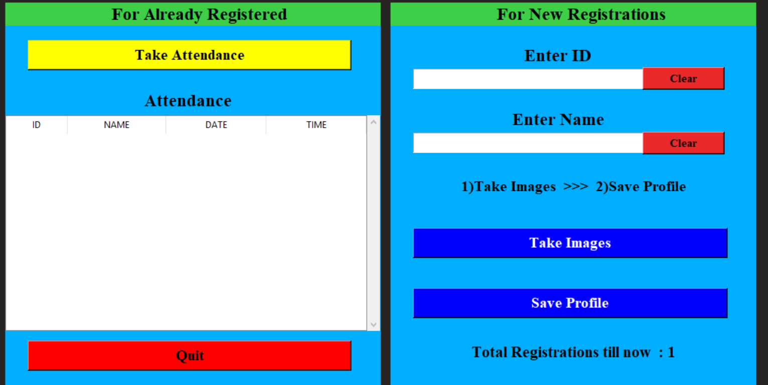
Screen 2:
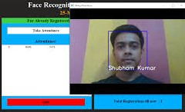

Screen 3:
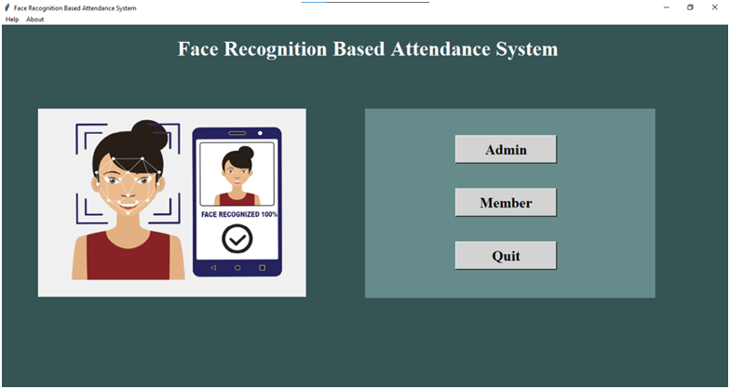

(Graph paper works well.)

6.3. Screen Objects and Actions
In this section, we define the key screen objects (UI components) and the corresponding actions (events triggered by user interactions) that form part of the Face Recognition Attendance System. These objects are the core elements of the user interface, and their functionality ensures the smooth operation of the system.

1. Login Page

Screen Objects:
- Username Field: A text input field for users to enter their username.
- Password Field: A password input field for users to enter their password securely.
- Login Button: A button that submits the login form and authenticates the user.
- Forgot Password Link: A link that redirects users to a password recovery page (if applicable).
- Sign Up Link: A link that redirects users to the registration page for creating a new account.

Actions:
- Enter Username and Password: The user types their login credentials into the respective fields.
- Click Login Button: When the user clicks the login button, the system validates the credentials and logs the user in, redirecting them to the dashboard if successful.
- Click Forgot Password: If the user forgets their password, they click this link to initiate the password recovery process.
- Click Sign Up: If the user is new, they click on the sign-up link to register for the system.

2. Registration Page

Screen Objects:
- Full Name Field: A text input field for the user to enter their full name.
- Email Field: A text input field for the user to enter their email address.
- Username Field: A text input field for the user to create a unique username.
- Password Field: A password input field for the user to enter their password.
- Upload Profile Picture: A file input field to upload the user’s profile image for face recognition.
- Register Button: A button that submits the registration form and saves user data.
- Back to Login Link: A link to redirect the user back to the login page.

Actions:
- Enter User Information: The user fills in their full name, email, username, and password in the respective fields.
- Upload Profile Picture: The user uploads a photo of themselves to be used for face recognition.
- Click Register Button: After completing the form, the user clicks this button to register their details. The system saves the information and facial data, proceeding to the login page.
- Click Back to Login: If the user already has an account, they can return to the login page.

3. Dashboard (For End Users)

Screen Objects:
- Welcome Message: A greeting message that welcomes the user (e.g., "Welcome, [Username]!").
- Mark Attendance Button: A button that triggers the webcam for face recognition and attendance marking.
- Attendance History Button: A button that navigates to the user's attendance records page.
- Logout Button: A button to log the user out of the system.

Actions:
- Click Mark Attendance Button: The user clicks this button to begin the face recognition process, where the webcam will be activated to scan the user’s face.
- Click Attendance History Button: The user clicks this button to view their attendance history, including present/absent status.
- Click Logout Button: The user clicks the logout button to end their session and return to the login page.

4. Attendance Marking Interface

Screen Objects:
- Live Webcam Feed: The live video stream captured from the webcam.
- Face Detection Frame: A bounding box around the detected face in the webcam feed.
- Recognition Status Message: A message indicating whether the face was successfully recognized or not (e.g., "Face Detected!" or "Face Not Recognized").
- Retry Button: A button allowing the user to retry the face recognition process if the face was not recognized.

Actions:
- Start Webcam Feed: When the user clicks on the Mark Attendance Button from the dashboard, the webcam feed starts.
- Face Recognition Process: The system scans the user's face in real-time, and once it is detected, the Recognition Status Message shows whether the user’s face was successfully recognized.
- Click Retry Button: If face recognition fails, the user can click Retry to attempt the process again.
- Attendance Success: If the face is recognized, the system marks the user as Present, and a confirmation message (e.g., "Attendance successfully marked!") is displayed.

5. Attendance History Page (For End Users)

Screen Objects:
- Attendance Table: A table displaying the user’s attendance records, including columns for Date, Status (Present/Absent), and possibly the Location.
- Filter Options: Dropdown or input fields to filter the records by date range or attendance status.
- Back to Dashboard Button: A button to return to the main dashboard.

Actions:
- Filter Attendance Records: The user can filter their attendance history based on specific criteria, such as date or status.
- View Attendance Records: The user can view the table with their past attendance status.
- Click Back to Dashboard: The user can return to the dashboard by clicking the Back to Dashboard Button.

6. Administrator Dashboard

Screen Objects:
- User Management Section: A list or table of all users registered in the system.
- Add User Button: A button to manually add a new user to the system.
- Generate Attendance Reports Button: A button to generate attendance reports for all users.
- System Settings Link: A link to configure system settings like face recognition thresholds.
- Logout Button: A button to log out the administrator.

Actions:
- Click Add User Button: The administrator clicks this button to add a new user manually by entering their information (name, email, etc.).
- Click Generate Attendance Reports Button: The admin clicks this button to view or download attendance reports.
- Click System Settings Link: The administrator clicks this link to configure system-wide settings.
- Click Logout Button: The admin clicks this button to log out of the admin panel.

7. Attendance Report Generation Page (Administrator)

Screen Objects:
- Report Filter Options: Dropdown or input fields to select date range, user, and attendance status.
- Generate Report Button: A button that triggers the generation of a report based on the selected filters.
- Export Report Button: A button to export the generated report in formats like PDF or CSV.
- Attendance Report Table: A table displaying the filtered attendance records.

Actions:
- Select Filter Options: The admin selects the criteria for generating the report (e.g., date range, user, or attendance status).
- Click Generate Report Button: The admin clicks the button to generate a report based on the filters.
- Click Export Report Button: The admin clicks this button to download the generated report in their desired format.

Requirements Matrix
- The Requirements Matrix is a tool that maps system requirements to specific functionalities and components within the Face Recognition Attendance System. It provides a clear, organized view of how each requirement is addressed in the system and ensures that all requirements are met during the development and testing phases. Below is a sample matrix detailing the functional, non-functional, and system requirements of the project.

7.1. Functional Requirements
ID | Requirement Description | Component(s) Addressed | Priority | Status
FR1 | User registration with personal details and facial data upload. | Registration Page, User Management | High | Completed
FR2 | User login with username and password. | Login Page, Authentication Module | High | Completed
FR3 | Face recognition to mark attendance. | Face Recognition Module, Webcam Integration | High | Completed
FR4 | Real-time webcam feed and face detection during attendance marking. | Attendance Marking Interface | High | Completed
FR5 | Display of attendance history for users (dates and attendance status). | Attendance History Page, Database Interaction | Medium | Completed
FR6 | Admin functionality to generate attendance reports (filter by user and date). | Administrator Dashboard, Reporting Module | High | Completed
FR7 | Admin functionality to manage user accounts (add, edit, delete users). | Admin Dashboard, User Management | High | Completed
FR8 | Admin view of all attendance logs with filter options. | Admin Dashboard, Reporting Module | High | Completed
FR9 | Email notifications for successful/failed attendance marking (optional). | Notification System, Backend Processing | Low | Planned
FR10 | Role-based access control for users and administrators. | Authentication & Security, User Roles | High | Completed

7.2. Non-Functional Requirements
ID | Requirement Description | Component(s) Addressed | Priority | Status
NFR1 | The system should be scalable to handle increasing numbers of users. | Backend Architecture, Database | High | In Progress
NFR2 | The system should provide real-time feedback during face recognition. | Face Recognition Module, Webcam Feed | High | Completed
NFR3 | The system must ensure data security and user privacy, especially for sensitive data (e.g., facial data, passwords). | Authentication & Security, Database Encryption | High | Completed
NFR4 | The user interface must be responsive across different devices (desktops, tablets, mobile phones). | Frontend (HTML, CSS, JS), Responsive Design | High | Completed
NFR5 | The system should be available 99% of the time (uptime). | System Infrastructure, Hosting | Medium | Planned
NFR6 | The system should support multi-language options (optional). | Frontend Design, Localization | Low | Planned
NFR7 | The system must process face recognition in under 5 seconds per user. | Face Recognition Module, Backend | High | In Progress
NFR8 | The system should generate reports in PDF and CSV formats. | Reporting Module, Export Functionality | Medium | Completed

